**Repeated measures ANOVA data and results for temperatures**

**data** Temp_Range_RMANOVA;

input Group Day_1 Day_2 Day_3 Day_4 Day_5 Day_6 Day_7 Day_8 Day_9 Day_10 Day_11 Day_12 Day_13 Day_14 Day_15;

datalines;

1 1.3 1.5 2.2 1.3 1.9 1.9 0.7 1.2 2.6 1.4 2.4 1.2 1.1 1.7 1.8

1 0.6 1.4 1.2 0.9 1.9 1.9 0.6 1.6 2.4 1.1 1.9 1.3 1.3 1.4 1.3

1 0.5 0.8 1.6 0.4 1.4 2.1 0.6 1.4 1.9 1.1 2.3 1.2 0.9 1.5 1.4

1 0.3 0.3 1.3 1.4 1.4 1.5 0.4 1.5 1.4 1.2 2.3 1.2 1.2 1.7 1.5

1 0.3 -0.3 2.3 0.4 1.1 1.4 0.1 1.0 1.5 1.0 1.9 0.9 0.9 1.5 1.8

1 -0.1 -0.2 1.4 0.3 1.7 1.4 0.8 1.5 1.7 1.3 2.4 1.2 0.8 1.3 1.6

1 -0.1 -0.2 1.4 1.0 1.5 1.2 0.7 1.7 1.4 1.4 2.3 1.1 0.8 1.6 1.7

1 0.9 -0.9 1.7 0.4 1.2 1.3 0.5 1.6 1.3 1.3 2.2 1.3 0.8 1.4 1.8

1 0.1 -0.4 1.6 -0.1 1.0 1.0 0.3 1.6 1.4 1.8 2.1 1.0 0.8 1.4 1.7

1 0.1 -0.7 1.0 1.4 1.5 1.2 0.2 1.1 1.3 1.0 2.1 0.7 0.7 1.3 1.4

2 0.0 -1.2 1.4 1.1 1.5 0.7 0.0 1.2 1.3 0.9 2.3 1.0 0.6 1.4 2.1

2 0.3 -1.4 1.6 0.3 1.1 0.8 -0.1 1.1 1.7 1.0 2.4 1.0 0.7 1.5 1.9

2 1.4 -0.6 1.9 0.9 1.5 1.0 0.1 0.9 1.8 1.3 2.2 1.0 0.8 1.3 1.6

2 1.2 -0.9 2.0 0.8 1.3 1.3 0.0 0.8 1.8 1.6 2.6 0.8 0.8 1.4 1.6

2 0.2 -1.1 2.2 0.7 0.3 0.8 0.7 1.4 1.6 1.6 2.7 1.0 0.9 1.4 2.1

2 0.1 -1.1 0.1 0.6 0.3 0.6 0.1 1.3 1.4 1.1 2.1 0.7 0.8 1.3 1.7

2 -0.1 -1.1 1.4 1.1 1.0 0.9 0.1 1.2 1.3 1.5 2.1 1.0 0.8 1.4 1.9

2 0.5 -0.7 1.6 0.2 0.3 0.9 0.2 1.3 1.7 1.4 2.1 1.1 0.6 1.3 1.6

2 0.1 -1.6 1.3 0.6 0.6 1.1 0.4 1.3 1.8 1.4 2.4 1.0 0.8 1.4 1.5

2 0.2 -0.6 2.0 0.6 0.6 2.0 0.4 1.5 1.9 1.3 2.6 1.1 0.9 1.5 1.8

3 0.1 -0.1 1.3 0.9 0.6 1.8 0.5 1.0 1.7 1.0 2.2 1.0 0.8 1.3 1.7

3 0.9 -0.6 1.9 1.0 0.8 2.0 0.3 1.1 1.9 1.3 2.4 0.8 0.8 1.3 1.8

3 0.6 -0.3 2.3 0.8 1.0 1.9 0.1 1.2 1.6 1.6 2.4 1.1 1.1 1.5 2.0

3 0.9 0.1 1.8 1.2 0.8 1.6 0.4 1.1 1.6 0.9 2.1 1.3 1.0 1.3 1.6

3 1.0 0.4 2.8 1.0 0.7 2.2 0.4 1.5 1.6 1.2 2.4 0.9 0.8 1.2 2.2

3 0.9 0.2 1.9 1.3 1.4 2.2 0.5 1.4 1.7 1.6 2.5 1.2 0.9 1.4 1.8

3 1.1 0.2 1.7 1.5 1.1 1.9 0.5 1.4 1.7 1.6 2.4 1.1 0.8 1.6 1.9

3 0.8 -0.2 1.7 1.0 0.6 1.8 0.1 1.6 1.3 1.5 2.6 1.0 1.1 1.4 1.8

3 0.8 0.1 1.9 1.3 0.9 2.1 0.3 1.6 2.1 1.6 2.9 0.9 0.9 1.6 1.6

3 -0.4 0.2 1.7 1.8 0.9 2.5 0.3 2.1 1.9 1.2 2.4 1.3 1.2 1.5 1.7

4 0.5 0.3 2.4 0.9 1.4 2.1 0.4 1.1 1.9 1.3 2.8 0.8 1.2 1.5 2.0

4 0.8 0.7 2.4 1.6 1.4 2.4 0.3 1.2 1.8 1.6 2.8 0.8 0.9 1.6 2.1

4 0.3 0.4 2.3 1.4 1.5 2.4 0.2 1.1 1.6 1.1 2.9 0.6 0.8 1.3 1.7

4 1.0 0.6 2.1 1.7 0.9 2.6 0.3 1.2 1.7 0.9 2.6 0.8 1.0 1.3 1.9

4 0.5 0.9 2.2 1.0 1.4 2.4 0.8 1.4 1.6 1.1 2.6 0.8 1.1 1.4 1.7

4 0.1 0.8 1.3 1.5 1.4 2.1 0.6 1.4 1.6 1.3 2.4 1.4 0.8 1.4 1.5

4 0.6 0.9 2.1 1.3 1.2 2.6 0.5 1.3 1.8 1.3 2.8 1.1 1.1 1.7 1.5

4 1.0 0.6 2.3 0.6 1.1 2.5 0.2 1.4 1.6 1.6 2.8 1.0 0.9 1.6 2.0

4 0.4 1.3 2.1 1.4 1.3 2.2 0.6 1.6 1.6 1.9 2.6 1.1 1.1 1.5 1.6

4 0.6 1.1 2.3 1.4 1.1 1.9 0.3 1.5 1.6 1.4 2.4 1.2 1.3 1.8 1.8

5 1.3 1.4 2.4 1.3 1.2 2.2 0.6 1.8 1.8 1.5 2.7 1.2 1.4 1.6 1.8

5 1.1 0.9 1.9 1.3 1.1 2.3 0.5 1.6 2.0 1.3 2.7 1.5 1.3 1.6 1.9

5 1.4 1.4 2.8 1.4 1.2 2.3 0.7 1.8 1.9 1.8 2.3 1.5 1.1 1.8 2.0

5 1.2 1.3 2.0 1.6 1.5 2.5 0.8 1.7 1.9 1.6 2.7 1.2 1.3 1.8 1.9

5 0.8 0.9 2.1 1.2 0.8 2.4 0.4 1.3 1.7 1.5 2.5 1.1 1.1 1.8 2.0

5 0.9 1.2 1.9 1.4 1.2 1.9 0.8 1.3 1.7 1.1 2.4 1.1 1.1 1.6 1.9

5 1.1 1.8 2.4 1.8 1.4 2.6 1.0 1.3 2.1 1.0 2.6 0.8 1.9 1.9 1.9

5 1.3 1.6 2.8 1.9 1.4 2.5 1.1 1.8 2.3 1.5 2.6 1.2 1.4 1.7 2.1

5 0.9 1.8 2.6 1.8 1.6 2.3 1.0 1.4 2.1 1.6 2.8 1.5 1.3 1.8 2.0

5 0.9 1.6 2.6 1.4 1.6 2.6 0.8 1.3 2.1 1.5 2.9 1.2 1.1 1.8 1.9

6 1.3 1.6 2.9 1.3 2.1 2.4 1.1 1.8 2.3 1.6 2.9 1.5 1.3 1.9 2.3

6 1.7 1.4 2.4 1.3 2.6 2.8 0.9 1.8 2.1 1.8 2.6 1.5 1.2 1.8 2.2

6 1.6 1.6 2.1 1.6 1.9 2.6 0.9 1.6 1.9 1.9 2.3 1.5 1.1 1.9 2.0

6 1.3 1.4 2.4 1.2 2.1 2.4 0.9 1.2 1.9 1.3 2.8 1.1 1.2 1.9 2.0

6 1.4 2.3 2.6 1.3 2.1 2.8 1.3 2.1 2.1 1.4 2.5 1.1 1.4 1.8 2.1

6 1.8 1.4 2.6 1.8 2.3 2.9 1.0 1.0 2.0 1.6 2.6 1.3 1.1 1.9 2.2

6 1.6 2.0 2.3 1.8 2.3 2.6 1.2 1.3 1.9 1.6 2.8 1.4 1.3 1.8 2.0

6 1.4 2.0 2.4 1.1 1.8 2.5 0.4 0.6 1.9 1.6 2.9 1.5 1.2 1.8 2.1

6 1.5 2.6 2.4 1.9 2.1 2.7 1.1 1.1 2.0 1.3 2.8 1.4 1.3 1.9 1.9

6 1.6 1.5 2.2 1.4 2.4 2.4 1.2 1.2 2.1 1.8 2.8 1.6 1.4 1.8 2.0

7 1.9 1.8 2.5 1.8 1.8 2.4 1.3 1.3 2.1 1.9 2.6 1.5 1.8 1.9 2.1

7 1.7 1.8 2.0 1.8 1.9 2.8 1.2 1.4 2.3 1.9 2.9 1.8 1.2 1.9 1.9

7 1.4 2.6 2.5 1.7 1.9 2.6 1.1 1.1 2.2 1.7 2.4 1.6 1.1 1.8 2.1

7 1.3 2.0 2.1 1.3 2.6 2.6 1.3 1.2 2.1 1.6 2.3 1.5 1.1 1.8 1.9

7 1.0 2.8 1.9 1.4 2.1 3.4 1.2 1.3 2.3 1.6 2.5 1.7 1.4 1.9 1.9

7 1.6 2.1 1.9 1.6 2.2 2.4 1.4 1.3 2.4 1.8 2.7 1.7 1.2 1.9 2.0

7 1.1 2.3 2.2 1.3 1.9 2.3 1.2 1.1 2.4 1.4 2.8 1.5 1.1 1.9 2.1

7 1.5 2.0 2.7 1.8 2.4 2.4 1.3 1.0 2.1 1.6 2.9 1.4 1.3 1.8 2.1

7 1.0 1.3 2.0 1.4 1.8 1.6 1.0 1.0 2.1 1.1 2.6 1.7 1.1 1.9 1.9

7 1.1 0.6 2.6 1.6 2.1 2.3 1.2 0.9 2.2 1.8 2.3 1.6 1.4 2.0 1.9

8 0.9 1.9 2.6 1.6 1.3 2.5 1.1 2.2 2.1 1.8 2.4 1.9 1.6 2.0 2.0

8 1.0 2.5 2.9 1.4 1.4 2.3 1.1 2.1 2.3 1.6 2.3 2.4 1.6 1.9 2.0

8 0.8 1.9 1.8 1.6 1.4 2.2 0.3 1.9 2.0 1.5 2.2 2.2 1.4 1.8 1.9

8 1.1 2.1 2.3 1.9 0.8 2.6 1.0 2.3 2.3 1.8 2.6 1.8 1.5 1.8 2.0

8 0.9 2.1 1.9 1.4 1.1 2.7 1.1 2.2 2.2 1.8 2.4 1.8 1.3 2.0 2.0

8 1.4 1.9 2.1 1.7 2.3 2.2 1.0 2.1 2.2 1.7 2.6 1.8 1.4 1.8 1.9

8 1.2 1.9 2.3 1.9 2.1 2.7 0.9 2.1 2.2 1.4 2.4 1.7 1.6 1.6 2.0

8 1.4 2.4 2.2 1.4 1.8 2.4 1.3 2.1 2.3 1.8 2.8 2.5 1.5 1.9 2.0

8 1.3 1.7 2.1 1.4 2.1 2.8 1.3 2.0 2.1 1.8 2.7 1.9 1.6 1.7 2.1

8 1.4 1.8 2.1 1.9 1.7 2.2 1.1 1.8 2.0 1.5 2.5 2.0 1.4 1.8 1.9

9 1.4 1.3 2.4 1.8 2.1 2.9 1.3 1.6 2.3 1.7 2.6 1.5 1.1 2.1 1.9

9 0.4 1.4 2.6 1.9 2.2 2.9 1.1 1.5 2.1 1.8 2.9 1.6 1.6 1.9 2.1

9 0.9 1.4 2.6 1.4 1.9 2.8 1.3 1.8 2.2 1.5 2.5 1.5 1.4 1.9 2.0

9 0.3 1.5 2.1 1.4 1.9 2.4 1.1 2.2 2.1 1.4 2.7 1.5 1.3 1.9 1.9

9 1.0 1.5 2.7 1.6 1.8 2.8 0.9 2.0 2.2 2.0 2.2 1.7 1.6 1.8 1.9

9 0.9 1.4 2.4 1.7 1.6 2.8 0.9 2.1 2.0 1.9 2.4 1.8 1.4 1.9 2.1

9 1.3 1.9 2.9 1.7 1.8 2.6 1.2 1.7 2.2 1.6 2.3 1.3 1.4 1.9 2.1

9 0.3 1.8 2.2 1.2 1.9 2.4 0.8 1.5 2.1 1.6 2.6 1.5 1.2 2.2 1.9

9 0.5 1.5 2.6 1.6 1.8 2.6 1.1 1.8 2.1 1.8 2.6 1.3 1.3 2.0 2.0

9 1.2 2.0 1.9 1.4 1.4 2.5 0.7 1.8 1.9 1.9 2.9 1.5 1.5 2.0 1.9

1 1.1 1.4 0.4 1.6 2.3 1.9 1.8 2.1 2.6 2.3 1.9 1.9 1.7 1.4 1.4

1 0.8 1.8 1.8 1.4 1.7 1.6 1.7 2.3 2.3 2.3 1.7 2.0 1.6 1.3 1.4

1 1.1 1.3 1.2 1.1 1.8 1.1 1.7 2.1 2.4 2.0 1.9 1.6 1.4 1.7 1.4

1 0.8 1.6 0.4 0.8 1.9 0.9 1.6 2.0 2.5 2.1 1.8 1.6 1.4 1.3 1.4

1 1.0 1.3 0.2 0.1 1.7 1.2 1.8 1.9 2.2 1.9 1.6 1.5 1.1 1.3 1.2

1 1.1 1.5 0.6 0.4 1.9 1.7 1.9 1.7 2.2 1.9 1.9 1.6 0.7 1.1 1.3

1 0.9 1.4 0.4 0.3 1.3 0.1 1.6 1.4 2.1 1.8 1.6 1.4 0.7 1.3 1.3

1 0.6 1.2 -0.1 0.1 1.8 0.6 1.5 1.4 2.1 2.0 1.6 1.4 0.6 1.5 1.4

1 1.3 1.3 0.3 0.5 1.7 0.8 1.9 1.6 1.9 1.9 1.8 1.5 0.6 1.4 1.4

1 0.4 1.0 0.3 0.7 1.8 0.8 1.4 1.4 1.7 1.8 1.6 1.3 0.2 1.3 1.5

2 0.7 1.6 1.1 1.1 2.8 0.5 1.3 1.1 1.4 1.4 1.6 1.0 0.7 1.1 1.0

2 1.1 1.3 1.1 1.3 2.1 0.6 1.6 1.0 1.6 1.5 1.3 1.1 0.6 1.3 1.1

2 0.6 1.4 1.3 0.8 1.7 0.6 1.5 1.0 1.6 1.6 1.4 1.1 0.8 1.1 1.3

2 0.6 1.1 0.9 1.1 1.1 0.3 1.3 0.8 1.6 1.6 1.6 1.1 1.0 1.5 1.5

2 0.5 1.1 1.0 0.8 1.6 0.7 1.1 0.9 1.6 1.4 1.4 1.1 1.0 1.4 1.3

2 1.3 1.6 0.6 -0.1 1.7 0.6 1.1 0.8 1.6 1.6 1.6 1.1 0.9 1.3 1.3

2 1.1 1.2 0.9 0.1 1.4 1.1 0.6 0.6 1.6 1.8 1.9 . 1.1 1.4 1.1

2 0.3 1.5 0.5 0.3 1.7 1.1 0.9 0.7 1.9 1.9 1.8 . 1.1 1.7 1.3

2 0.9 1.3 0.9 0.7 1.8 1.3 1.0 0.8 1.1 2.0 1.8 . 1.1 1.6 1.1

2 0.6 1.0 1.0 0.3 1.6 1.0 1.3 1.1 1.9 1.9 2.3 . 1.2 1.6 1.3

3 1.7 0.9 1.3 1.2 2.3 2.1 1.1 1.6 1.8 1.7 2.5 . 1.0 1.3 1.3

3 1.3 0.8 1.1 0.9 1.8 1.9 1.3 2.2 1.9 1.8 2.1 . 1.1 1.4 1.2

3 0.1 0.7 0.8 0.7 1.7 1.6 1.2 2.2 2.3 1.8 1.8 . 1.3 1.4 1.4

3 1.5 0.8 0.7 0.8 1.8 1.3 1.1 1.8 2.1 2.1 1.8 . 1.9 1.3 1.1

3 1.3 1.3 0.5 0.7 1.8 1.6 1.4 1.6 1.9 1.8 1.8 . 1.8 1.4 1.1

3 0.5 1.4 0.3 0.4 1.6 1.3 1.3 1.6 2.6 1.9 1.9 . 1.9 1.4 1.1

3 1.0 1.1 0.3 0.9 1.6 1.7 1.4 1.4 2.5 1.8 2.0 . 1.9 1.4 1.1

3 1.3 1.8 0.8 0.6 2.1 1.6 1.3 1.3 2.6 2.0 2.1 . 1.6 1.6 1.3

3 1.5 1.4 0.4 0.8 1.6 1.8 1.2 1.4 2.1 2.0 1.9 . 1.6 1.3 1.1

3 1.1 1.1 0.4 0.7 1.8 1.0 1.4 0.6 2.1 1.8 2.0 . 1.6 1.3 1.6

4 1.0 1.9 0.5 1.5 1.9 1.6 2.1 1.3 2.0 2.3 1.5 . 1.8 1.4 0.9

4 0.8 0.4 1.3 1.5 1.4 1.8 1.6 1.6 1.9 2.1 1.7 . 1.4 1.4 1.5

4 0.4 1.4 0.4 1.3 1.4 1.7 1.5 1.2 1.9 1.9 1.8 . 1.3 1.3 1.4

4 0.4 1.1 -0.1 1.4 1.6 1.3 1.6 1.4 2.1 2.1 2.0 . 1.3 1.4 1.6

4 0.0 1.3 -0.1 1.3 1.4 1.5 1.5 1.3 2.1 2.0 2.1 . 1.5 1.3 1.1

4 0.9 1.6 0.9 1.5 1.9 1.6 1.9 1.3 2.3 2.3 1.9 . 1.4 1.5 1.4

4 1.0 1.6 0.4 1.9 2.3 2.0 1.4 1.6 2.4 2.1 2.3 . 1.8 1.6 1.1

4 0.5 1.4 -0.2 1.1 2.1 1.6 1.3 1.1 2.0 2.1 1.9 . 1.5 1.6 1.1

4 1.1 1.8 1.1 1.1 2.1 2.0 1.2 1.3 1.9 2.2 1.9 . 1.5 1.5 1.2

4 0.9 1.6 -0.2 1.4 1.8 1.8 1.3 1.0 2.0 1.8 1.9 . 1.3 1.5 1.3

5 0.9 1.8 1.3 1.8 2.3 1.9 1.5 2.6 2.5 2.3 2.0 . 1.5 2.1 1.3

5 1.1 1.9 1.1 1.6 2.1 2.1 1.8 2.5 2.4 2.2 2.1 . 1.5 1.9 1.3

5 1.2 1.7 1.1 1.6 2.2 1.8 1.5 2.3 2.4 2.2 1.9 . 1.4 2.0 1.4

5 1.4 1.8 1.4 1.3 1.7 1.5 1.8 2.3 2.6 2.5 1.8 . 1.4 1.8 1.1

5 1.1 2.0 1.7 1.8 2.4 2.0 1.9 2.4 2.4 2.5 2.0 . 1.6 2.1 1.1

5 1.3 2.4 1.9 1.8 2.5 1.8 2.1 1.8 2.7 2.4 2.1 . 1.8 2.0 1.3

5 1.2 1.9 1.8 2.1 2.9 1.9 1.5 1.5 2.4 2.3 2.0 . 1.7 2.1 1.3

5 1.1 2.1 1.9 1.5 1.9 1.8 1.6 1.5 2.2 2.4 1.9 . 1.3 1.9 1.1

5 0.8 2.4 1.8 1.1 2.0 1.7 1.9 1.3 2.3 2.3 1.8 . 1.4 1.8 1.3

5 1.3 1.8 1.9 1.9 2.1 1.8 1.8 0.7 2.2 2.2 1.8 . 1.4 1.9 1.3

6 1.5 1.5 1.7 1.7 1.6 2.0 1.5 1.0 2.3 2.1 1.8 . 1.1 1.9 1.1

6 0.7 2.1 1.5 1.8 1.4 1.8 1.6 0.8 2.0 1.9 1.9 . 1.4 1.9 1.3

6 0.9 1.6 1.6 1.1 1.2 1.8 1.5 0.7 2.0 2.1 1.8 . 1.0 1.7 1.2

6 0.7 1.5 2.1 1.6 1.0 1.9 1.4 0.8 2.1 2.3 1.9 . 0.9 1.7 1.1

6 1.3 2.4 1.8 1.5 1.3 1.9 1.4 0.4 2.0 2.4 1.8 . 1.0 1.8 1.3

6 1.2 1.5 1.3 1.4 0.9 1.9 1.6 0.6 2.0 2.1 2.1 . 1.3 1.9 1.4

6 1.1 1.7 1.4 1.7 1.1 1.9 1.3 0.4 2.1 2.2 2.0 . 1.2 1.9 1.3

6 1.1 1.8 1.5 1.5 0.8 1.8 1.5 0.6 2.3 2.1 2.0 . 1.2 1.8 1.5

6 0.8 1.6 1.2 1.6 1.1 1.6 1.8 0.2 2.1 1.9 1.9 . 1.2 1.8 1.2

6 0.6 1.4 1.1 1.8 1.0 1.8 1.6 0.3 2.3 2.1 2.1 . 1.4 1.9 1.4

7 1.2 1.9 1.4 1.6 1.9 2.0 2.0 2.6 2.6 2.1 2.1 . 2.0 2.0 1.4

7 1.3 2.1 1.9 1.4 1.4 1.9 2.0 2.7 2.6 2.3 2.1 . 1.8 1.9 1.3

7 1.6 2.1 1.9 1.6 1.6 1.8 2.1 2.2 2.4 2.2 2.1 . 1.8 1.9 1.3

7 1.6 1.9 1.8 1.7 1.7 1.8 2.1 2.3 2.6 2.5 2.2 . 1.9 1.9 1.2

7 1.4 2.2 1.9 1.9 1.5 1.6 1.9 2.1 2.3 2.5 2.1 . 1.4 1.9 1.1

7 0.8 1.9 1.6 1.3 1.1 1.9 1.8 2.1 2.3 2.3 2.1 . 1.6 2.0 1.3

7 1.2 1.9 1.5 1.4 1.1 1.4 1.4 1.7 2.4 2.2 2.1 . 1.6 2.0 1.3

7 1.2 1.9 1.4 1.9 0.8 1.9 2.3 1.8 2.3 2.3 2.1 . 1.7 2.1 1.4

7 0.8 1.5 1.4 1.7 0.8 1.8 1.9 1.9 2.3 2.2 2.2 . 1.5 1.9 1.3

7 1.4 1.8 1.6 1.8 1.2 2.0 2.0 1.7 2.3 2.3 2.0 . 1.3 1.9 1.4

8 2.6 1.9 2.3 1.9 1.3 2.2 2.8 2.3 2.8 2.3 1.9 . 1.5 2.0 1.3

8 0.9 2.0 2.1 1.9 1.1 2.1 2.0 2.5 2.5 2.5 2.1 . 1.8 2.0 1.1

8 1.1 1.8 1.0 1.4 1.4 2.1 1.9 2.1 2.4 2.6 2.1 . 1.6 1.6 1.3

8 1.3 2.1 0.6 1.4 1.3 1.8 1.5 1.9 2.3 2.4 1.9 . 1.8 1.9 1.4

8 1.1 2.0 0.5 1.3 1.3 1.8 1.8 2.7 2.1 2.3 1.9 . 1.8 1.9 1.4

8 1.4 2.1 0.9 1.9 2.2 1.9 1.9 2.6 2.3 2.4 1.8 . 1.5 1.8 1.3

8 2.1 2.3 0.9 2.0 1.9 2.2 1.9 2.8 2.3 2.6 2.0 . 1.6 1.8 1.3

8 1.4 2.6 1.1 1.8 1.3 2.0 1.8 2.8 2.4 2.7 2.2 . 1.6 1.9 1.3

8 1.5 2.6 1.7 1.7 1.3 2.0 2.1 2.9 2.3 2.6 2.0 . 1.6 1.8 1.1

8 1.4 2.3 1.8 2.0 1.5 2.1 1.7 2.6 2.3 2.3 2.4 . 1.8 2.0 1.4

9 1.9 1.9 2.3 1.9 1.4 2.2 2.8 2.3 2.8 2.5 1.9 . 1.5 2.0 1.1

9 2.4 2.0 2.1 1.9 1.7 2.1 2.0 2.5 2.5 2.6 2.3 . 1.4 2.0 1.3

9 1.4 1.8 1.0 1.4 1.1 2.1 1.9 2.1 2.4 2.0 1.9 . 1.6 1.6 1.1

9 1.5 2.1 0.6 1.4 1.3 1.8 1.5 1.9 2.1 2.4 2.0 . 1.3 1.9 1.1

9 1.3 2.0 0.5 1.3 1.0 1.8 1.8 2.7 2.3 2.3 1.9 . 1.5 1.9 1.2

9 1.1 2.1 0.9 1.9 1.6 1.9 1.9 2.6 2.8 2.6 2.0 . 1.7 1.8 1.5

9 1.0 2.3 0.9 2.0 1.4 2.2 1.9 2.8 2.4 2.6 2.1 . 1.9 1.8 1.3

9 1.6 2.6 1.1 1.8 1.6 2.0 1.8 2.8 2.3 2.6 2.0 . 1.7 1.9 1.6

9 1.6 2.6 1.7 1.7 1.7 2.0 2.1 2.9 2.6 2.5 1.9 . 1.6 1.8 1.4

9 1.4 2.3 1.8 2.0 1.4 2.1 1.7 2.6 2.3 2.4 1.9 . 1.8 2.0 1.3

1 1.2 1.4 1.8 2.1 1.6 1.9 2.1 1.9 2.1 2.1 1.7 2.0 1.4 1.8 2.0

1 0.4 0.9 1.4 1.6 1.1 2.4 1.4 1.6 1.9 1.9 1.6 1.9 1.6 1.8 2.0

1 0.6 1.3 1.5 1.6 1.7 2.1 1.3 1.5 1.8 1.5 2.1 1.9 1.4 1.4 1.8

1 0.3 0.8 1.4 1.4 1.4 2.1 1.5 1.5 1.9 1.8 1.8 1.9 1.4 1.6 1.7

1 0.8 1.4 1.8 1.8 1.5 2.3 1.3 1.4 1.7 1.6 1.7 2.1 1.6 1.4 1.4

1 0.4 1.1 1.5 1.7 1.5 2.1 0.9 1.6 1.8 1.8 1.9 2.1 1.7 1.8 1.5

1 0.6 1.2 1.6 1.6 1.3 1.9 1.0 1.1 1.8 1.7 1.8 2.3 1.8 1.8 1.8

1 0.8 1.4 1.6 1.9 1.4 1.9 0.7 1.6 1.8 1.6 1.6 2.1 1.6 1.4 1.9

1 0.6 1.3 1.6 1.7 1.5 1.4 1.7 1.3 1.7 1.6 1.8 1.8 1.6 1.5 1.7

1 0.9 1.6 1.6 1.8 1.2 2.1 1.1 1.5 1.9 1.8 1.8 2.1 1.6 2.2 2.0

2 1.3 1.6 1.4 1.9 1.4 2.6 0.9 1.3 2.1 2.1 1.7 2.1 1.3 1.6 1.7

2 0.9 1.4 1.5 1.9 1.3 2.5 0.8 1.2 1.8 1.8 1.6 1.7 1.1 1.1 1.5

2 0.7 1.2 1.3 1.8 1.6 2.4 0.5 1.1 1.8 1.8 1.8 1.9 1.6 1.8 1.8

2 0.8 1.4 1.6 1.9 1.3 2.3 0.9 1.7 2.1 1.8 1.8 2.1 1.6 1.3 1.7

2 1.5 1.1 1.6 1.8 1.4 2.0 1.3 1.2 1.9 1.8 1.6 1.9 1.4 1.1 1.4

2 0.9 0.9 1.5 1.9 1.8 1.9 0.6 1.0 1.8 1.6 1.8 1.9 1.2 1.3 1.6

2 1.1 1.2 1.6 2.0 1.6 2.0 1.0 1.6 1.9 1.9 1.8 1.9 1.3 1.3 1.5

2 0.9 1.2 1.7 1.9 1.6 2.1 0.9 1.3 1.8 1.8 1.6 2.1 1.4 1.2 1.6

2 1.1 1.0 1.4 1.8 1.6 2.3 0.9 1.3 2 1.8 1.7 1.9 1.4 1.3 2.1

2 0.9 1.3 1.5 1.8 1.4 2.4 1.9 1.3 1.9 2.1 1.8 1.9 1.3 1.0 1.5

3 0.5 1.0 1.2 1.4 1.3 2.3 -0.1 1.0 1.9 1.7 1.4 1.6 1.3 1.8 1.4

3 1.1 1.3 1.3 1.9 1.3 2.2 1.0 1.7 2.1 1.9 1.6 1.9 1.5 1.1 1.5

3 1.2 1.3 1.4 2.0 1.5 2.6 0.9 1.7 2 1.9 1.8 1.7 1.5 1.0 1.4

3 1.0 1.1 1.0 1.9 1.3 2.4 2.8 1.5 1.9 2.1 1.5 1.8 1.4 1.3 1.9

3 0.9 1.0 1.5 2.0 1.6 2.6 1.4 1.5 2.1 2 1.7 1.9 1.8 1.4 1.8

3 1.0 1.1 1.5 1.9 1.4 2.3 1.3 1.6 1.9 1.9 1.7 1.8 1.6 1.3 2.1

3 1.3 1.3 1.8 2.0 1.3 2.4 2.0 1.8 2 2.4 1.9 2.0 1.7 1.4 1.7

3 1.0 1.3 1.7 1.9 1.9 2.2 1.3 1.4 1.9 2 1.6 2.1 2.0 1.4 1.9

3 0.9 1.1 1.6 1.9 1.4 2.1 1.4 1.8 2 2.1 1.9 2.0 1.5 1.7 1.6

3 1.1 1.2 1.7 1.9 1.4 2.0 1.8 1.3 1.9 2.1 2.0 2.1 1.6 1.6 1.6

4 0.9 1.0 1.3 2.1 1.1 1.6 0.8 1.6 1.9 2.3 1.7 1.6 1.5 1.5 1.8

4 1.0 0.9 1.2 1.6 1.8 2.3 0.7 1.5 2.3 2.4 1.6 1.8 1.4 1.2 1.6

4 1.1 0.9 1.4 1.8 1.4 2.0 1.8 1.8 2 2 1.8 1.9 1.5 1.5 1.8

4 0.6 1.1 1.3 2.0 1.6 2.1 0.8 1.6 2.2 2 1.5 1.9 1.5 1.3 1.4

4 1.1 1.3 1.5 2.1 1.8 2.3 0.9 1.4 2 1.9 1.9 2.1 1.6 1.8 1.5

4 0.9 1.1 1.7 1.8 1.7 2.1 2.0 1.4 2.1 1.9 2.1 1.9 1.8 1.7 1.5

4 0.8 1.0 1.5 2.1 1.5 2.6 1.0 1.9 2.1 2.2 1.8 1.9 2.1 1.6 1.3

4 1.1 1.3 1.7 2.1 1.8 2.3 0.9 1.6 2.1 1.9 1.8 1.9 1.8 1.4 1.2

4 1.2 1.7 1.9 2.2 1.8 2.4 1.2 1.4 1.9 1.6 1.8 1.9 1.6 1.6 1.3

4 0.9 1.4 1.8 2.1 2.0 2.0 0.9 1.6 2 1.9 1.9 1.8 1.7 1.8 1.3

5 0.9 1.2 1.9 2.6 1.8 1.9 0.8 1.3 2 2.2 1.8 2.4 1.4 1.3 0.3

5 0.6 0.9 1.9 2.1 1.8 1.6 0.7 0.9 2.4 2 1.6 2.1 1.4 1.5 0.9

5 0.6 1.0 1.7 2.2 1.5 2.0 1.8 1.5 2.1 2.1 2.1 1.9 1.6 1.3 0.9

5 0.8 1.1 1.4 2.3 1.6 2.0 2.1 1.5 2.1 2.1 1.7 2.1 1.8 1.4 0.9

5 0.9 1.2 1.7 1.9 1.7 2.0 0.9 1.4 2.3 2 1.8 2.3 1.8 1.6 0.9

5 0.5 1.1 1.8 2.4 1.8 2.0 1.4 1.7 2.2 2 2.1 2.0 1.9 1.8 1.0

5 1.1 1.3 1.8 2.1 1.9 2.0 1.3 1.6 2.1 2.0 1.8 2.2 1.8 1.6 1.0

5 1.8 1.2 1.8 2.1 1.8 2.1 1.4 1.6 2.1 1.6 1.9 2.0 1.9 1.6 0.9

5 0.9 1.1 1.4 2.1 1.8 2.1 0.9 1.4 2.1 2.1 1.9 1.9 1.8 1.8 0.8

5 1.3 1.3 1.6 2.5 1.8 2.9 2.2 1.6 2 2.6 2.0 2.1 2.2 1.6 0.8

6 1.3 1.6 2.0 2.5 1.9 2.4 2.3 2.3 2.6 2.6 2.5 2.4 2.1 2.1 1.7

6 1.0 1.6 2.2 2.1 1.8 2.4 2.2 2.1 2.3 2.3 2.2 2.4 1.9 2.0 1.6

6 1.2 1.4 2.1 2.1 2.1 2.4 1.8 2.3 2.4 2.4 2.1 2.2 1.7 2.1 1.4

6 1.1 1.3 1.8 1.9 1.9 2.4 1.3 1.9 2.1 2.2 2.1 2.2 1.8 2.0 1.4

6 1.4 1.8 2.3 2.9 2.1 2.5 2.1 1.9 2.5 2.3 2.0 2.3 1.9 2.0 1.2

6 1.1 1.6 1.9 2.4 1.8 3.0 1.9 2.1 2.4 2.3 2.0 2.3 2.4 1.9 1.3

6 1.0 1.3 2.1 2.3 1.7 2.7 1.5 1.9 2.3 2.1 2.1 2.4 1.8 2.0 1.5

6 1.1 1.5 2.1 2.4 1.9 2.2 1.6 2.0 2.8 2.3 2.1 2.3 1.8 1.8 1.2

6 1.6 1.6 2.3 2.8 1.8 2.4 1.9 1.8 2.5 2.4 2.0 2.1 1.8 1.8 1.3

6 1.1 1.6 1.8 2.2 1.6 2.1 1.5 1.7 2.3 2.6 1.9 2.2 2.2 2.0 1.2

7 1.1 1.7 2.6 2.2 1.9 2.2 1.4 2.3 2.6 2.6 2.0 2.6 2.1 2.3 1.3

7 1.1 1.8 2.3 2.1 2.1 2.4 1.7 2.1 2.3 2.3 1.9 2.6 2.3 2.0 1.2

7 1.3 1.6 2.3 2.3 1.9 2.3 2.1 2.1 2.3 2.4 1.9 2.6 1.8 1.9 1.4

7 1.3 1.8 2.2 2.1 1.8 2.1 2.5 2.0 2.3 2.3 1.9 2.4 1.8 1.9 1.3

7 1.9 1.7 2.2 2.0 1.8 2.4 1.6 2.1 2.3 2.3 1.9 2.5 1.8 2.0 1.4

7 1.3 1.7 2.1 2.6 1.9 2.4 1.9 2.0 2.3 2.3 1.8 2.4 1.8 2.1 1.3

7 1.4 1.9 2.0 2.1 2.0 2.1 1.8 2.1 2.3 2.3 1.9 2.5 1.9 2.1 1.2

7 1.3 1.3 1.9 2.4 1.8 2.3 1.3 2.0 2.2 2.1 1.8 2.3 1.9 2.1 1.2

7 1.4 1.4 1.9 2.1 2.1 2.1 1.9 2.1 2.3 2.3 1.8 2.2 1.8 1.9 0.9

7 1.4 1.7 1.8 2.3 1.9 2.4 1.6 1.8 2.3 2.1 2.0 2.4 2.0 2.0 1.0

8 1.6 1.1 1.7 2.3 2.2 2.8 1.4 1.7 2.4 2 1.9 1.6 1.8 1.9 1.6

8 0.4 1.2 1.9 2.6 2.1 2.5 1.4 1.6 2.3 2.3 2.3 1.8 1.7 1.8 1.4

8 0.6 1.1 1.6 1.9 1.6 2.3 1.3 1.7 2.1 2.1 2.1 1.8 2.1 1.8 1.3

8 1.3 1.4 1.8 2.0 1.8 2.8 1.4 1.7 2.3 2.3 2.1 1.7 1.8 1.6 1.6

8 1.4 1.4 2.0 2.6 2.2 2.7 2.3 2.1 2.3 2.4 2.1 2.2 1.9 1.9 1.6

8 0.8 1.4 2.1 2.4 1.7 2.7 2.0 2.1 2.2 2.3 2.1 2.1 2.0 2.0 1.6

8 0.8 1.3 1.9 1.9 2.1 2.6 1.7 2.0 2.3 2.3 2.0 2.2 2.0 1.9 1.8

8 1.1 1.3 2.1 2.7 2.0 3.0 1.3 2.0 2.3 2.3 2.1 2.2 2.2 1.8 1.7

8 1.4 1.6 2.1 2.4 1.8 2.3 1.6 2.2 2.3 2.3 2.3 2.3 2.0 1.9 1.5

8 1.8 1.5 2.1 2.1 1.8 2.4 1.8 1.9 2.2 2.8 1.9 2.1 1.9 1.8 1.5

9 1.3 1.9 2.3 2.6 2.0 2.8 2.6 2.4 2.4 2.3 1.9 2.4 2.4 2.3 1.6

9 0.8 1.4 2.2 2.4 1.8 2.5 1.4 1.9 2.3 2.1 2.3 2.6 2.1 2.5 1.6

9 1.1 1.7 2.1 2.1 1.6 2.3 1.5 1.9 2.1 2.1 2.1 2.5 2.0 2.1 1.4

9 1.0 1.5 2.1 2.4 1.8 2.8 1.5 2.1 2.3 2.5 2.1 2.4 1.8 2.5 1.4

9 1.3 1.7 2.0 2.6 1.9 2.7 1.9 1.4 2.3 2.3 2.1 2.6 2.1 2.1 1.9

9 1.8 1.8 2.2 2.9 1.6 2.7 1.9 2.3 2.2 2.1 2.1 2.6 2.4 2.3 1.4

9 1.1 1.5 2.1 2.8 2.1 2.6 1.5 1.9 2.3 2.3 2.0 2.2 2.3 1.9 1.8

9 1.3 1.9 2.1 2.6 2.0 3.0 1.9 2.0 2.3 2.1 2.1 2.1 2.1 2.1 1.6

9 1.2 1.4 2.0 2.4 1.9 2.3 1.8 2.1 2.3 2.3 2.3 2.4 1.9 1.9 1.7

9 1.3 1.8 2.1 2.3 2.3 2.4 1.8 2.0 2.2 2.3 1.9 2.1 1.8 1.9 1.6

;

**run**;

**proc** **print** data = Temp_Range_RMANOVA;

**run**;

**proc** **glm** data = Temp_Range_RMANOVA;

Class Group;

model Day_1-Day_15 = Group;

repeated Time;

**run**;

The GLM Procedure

Dependent Variable: Day_1

| **Source** | **DF** | **Sum of Squares** | **Mean Square** | **F Value** | **Pr > F** |
| --- | --- | --- | --- | --- | --- |
| **Model** | 8 | 12.26664887 | 1.53333111 | 11.86 | <.0001 |
| **Error** | 187 | 24.16682051 | 0.12923433 |  |  |
| **Corrected Total** | 195 | 36.43346939 |  |  |  |

| **R-Square** | **Coeff Var** | **Root MSE** | **Day_1 Mean** |
| --- | --- | --- | --- |
| 0.336686 | 37.47893 | 0.359492 | 0.959184 |

| **Source** | **DF** | **Type I SS** | **Mean Square** | **F Value** | **Pr > F** |
| --- | --- | --- | --- | --- | --- |
| **Group** | 8 | 12.26664887 | 1.53333111 | 11.86 | <.0001 |

| **Source** | **DF** | **Type III SS** | **Mean Square** | **F Value** | **Pr > F** |
| --- | --- | --- | --- | --- | --- |
| **Group** | 8 | 12.26664887 | 1.53333111 | 11.86 | <.0001 |

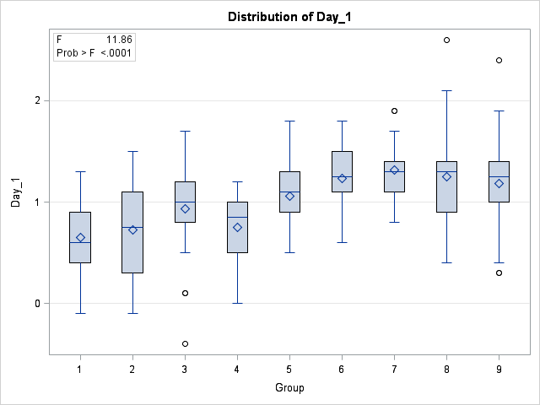

**The GLM Procedure**

Dependent Variable: Day_2

| **Source** | **DF** | **Sum of Squares** | **Mean Square** | **F Value** | **Pr > F** |
| --- | --- | --- | --- | --- | --- |
| **Model** | 8 | 47.2477336 | 5.9059667 | 15.10 | <.0001 |
| **Error** | 187 | 73.1267051 | 0.3910519 |  |  |
| **Corrected Total** | 195 | 120.3744388 |  |  |  |

| **R-Square** | **Coeff Var** | **Root MSE** | **Day_2 Mean** |
| --- | --- | --- | --- |
| 0.392506 | 53.59288 | 0.625341 | 1.166837 |

| **Source** | **DF** | **Type I SS** | **Mean Square** | **F Value** | **Pr > F** |
| --- | --- | --- | --- | --- | --- |
| **Group** | 8 | 47.24773365 | 5.90596671 | 15.10 | <.0001 |

| **Source** | **DF** | **Type III SS** | **Mean Square** | **F Value** | **Pr > F** |
| --- | --- | --- | --- | --- | --- |
| **Group** | 8 | 47.24773365 | 5.90596671 | 15.10 | <.0001 |

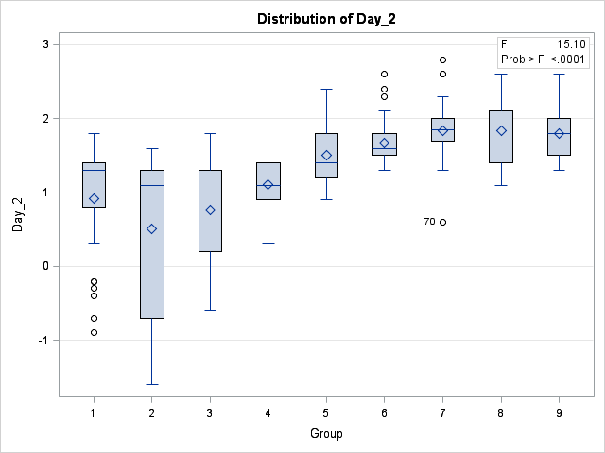

The GLM Procedure

Dependent Variable: Day_3

| **Source** | **DF** | **Sum of Squares** | **Mean Square** | **F Value** | **Pr > F** |
| --- | --- | --- | --- | --- | --- |
| **Model** | 8 | 27.75017792 | 3.46877224 | 20.19 | <.0001 |
| **Error** | 187 | 32.13512821 | 0.17184561 |  |  |
| **Corrected Total** | 195 | 59.88530612 |  |  |  |

| **R-Square** | **Coeff Var** | **Root MSE** | **Day_3 Mean** |
| --- | --- | --- | --- |
| 0.463389 | 22.54449 | 0.414543 | 1.838776 |

| **Source** | **DF** | **Type I SS** | **Mean Square** | **F Value** | **Pr > F** |
| --- | --- | --- | --- | --- | --- |
| **Group** | 8 | 27.75017792 | 3.46877224 | 20.19 | <.0001 |

| **Source** | **DF** | **Type III SS** | **Mean Square** | **F Value** | **Pr > F** |
| --- | --- | --- | --- | --- | --- |
| **Group** | 8 | 27.75017792 | 3.46877224 | 20.19 | <.0001 |

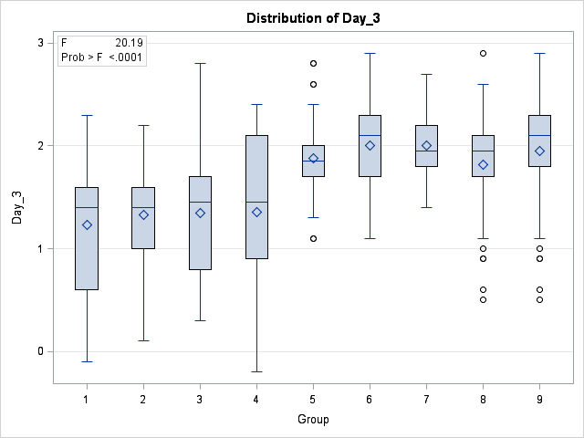

The GLM Procedure

Dependent Variable: Day_4

| **Source** | **DF** | **Sum of Squares** | **Mean Square** | **F Value** | **Pr > F** |
| --- | --- | --- | --- | --- | --- |
| **Model** | 8 | 25.16840398 | 3.14605050 | 11.72 | <.0001 |
| **Error** | 187 | 50.20282051 | 0.26846428 |  |  |
| **Corrected Total** | 195 | 75.37122449 |  |  |  |

| **R-Square** | **Coeff Var** | **Root MSE** | **Day_4 Mean** |
| --- | --- | --- | --- |
| 0.333926 | 31.83528 | 0.518135 | 1.627551 |

| **Source** | **DF** | **Type I SS** | **Mean Square** | **F Value** | **Pr > F** |
| --- | --- | --- | --- | --- | --- |
| **Group** | 8 | 25.16840398 | 3.14605050 | 11.72 | <.0001 |

| **Source** | **DF** | **Type III SS** | **Mean Square** | **F Value** | **Pr > F** |
| --- | --- | --- | --- | --- | --- |
| **Group** | 8 | 25.16840398 | 3.14605050 | 11.72 | <.0001 |

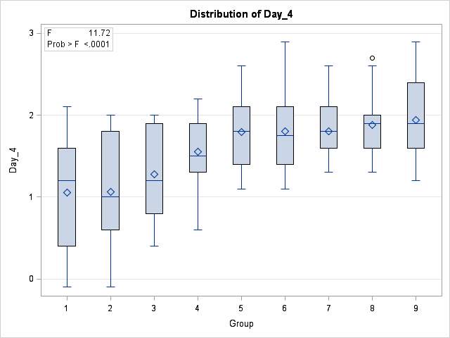

The GLM Procedure

Dependent Variable: Day_5

| **Source** | **DF** | **Sum of Squares** | **Mean Square** | **F Value** | **Pr > F** |
| --- | --- | --- | --- | --- | --- |
| **Model** | 8 | 14.88019990 | 1.86002499 | 15.46 | <.0001 |
| **Error** | 187 | 22.50082051 | 0.12032524 |  |  |
| **Corrected Total** | 195 | 37.38102041 |  |  |  |

| **R-Square** | **Coeff Var** | **Root MSE** | **Day_5 Mean** |
| --- | --- | --- | --- |
| 0.398068 | 21.44743 | 0.346879 | 1.617347 |

| **Source** | **DF** | **Type I SS** | **Mean Square** | **F Value** | **Pr > F** |
| --- | --- | --- | --- | --- | --- |
| **Group** | 8 | 14.88019990 | 1.86002499 | 15.46 | <.0001 |

| **Source** | **DF** | **Type III SS** | **Mean Square** | **F Value** | **Pr > F** |
| --- | --- | --- | --- | --- | --- |
| **Group** | 8 | 14.88019990 | 1.86002499 | 15.46 | <.0001 |

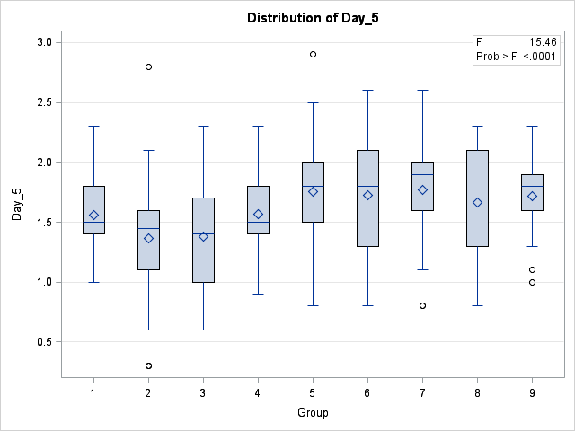

The GLM Procedure

Dependent Variable: Day_6

| **Source** | **DF** | **Sum of Squares** | **Mean Square** | **F Value** | **Pr > F** |
| --- | --- | --- | --- | --- | --- |
| **Model** | 8 | 38.78334668 | 4.84791833 | 26.74 | <.0001 |
| **Error** | 187 | 33.90905128 | 0.18133183 |  |  |
| **Corrected Total** | 195 | 72.69239796 |  |  |  |

| **R-Square** | **Coeff Var** | **Root MSE** | **Day_6 Mean** |
| --- | --- | --- | --- |
| 0.533527 | 20.08732 | 0.425831 | 2.119898 |

| **Source** | **DF** | **Type I SS** | **Mean Square** | **F Value** | **Pr > F** |
| --- | --- | --- | --- | --- | --- |
| **Group** | 8 | 38.78334668 | 4.84791833 | 26.74 | <.0001 |

| **Source** | **DF** | **Type III SS** | **Mean Square** | **F Value** | **Pr > F** |
| --- | --- | --- | --- | --- | --- |
| **Group** | 8 | 38.78334668 | 4.84791833 | 26.74 | <.0001 |

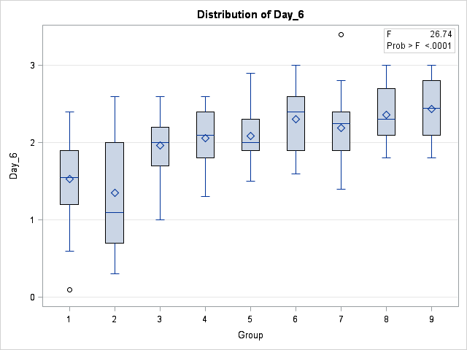

The GLM Procedure

Dependent Variable: Day_7

| **Source** | **DF** | **Sum of Squares** | **Mean Square** | **F Value** | **Pr > F** |
| --- | --- | --- | --- | --- | --- |
| **Model** | 8 | 14.61194898 | 1.82649362 | 6.48 | <.0001 |
| **Error** | 187 | 52.74050000 | 0.28203476 |  |  |
| **Corrected Total** | 195 | 67.35244898 |  |  |  |

| **R-Square** | **Coeff Var** | **Root MSE** | **Day_7 Mean** |
| --- | --- | --- | --- |
| 0.216948 | 47.18477 | 0.531069 | 1.125510 |

| **Source** | **DF** | **Type I SS** | **Mean Square** | **F Value** | **Pr > F** |
| --- | --- | --- | --- | --- | --- |
| **Group** | 8 | 14.61194898 | 1.82649362 | 6.48 | <.0001 |

| **Source** | **DF** | **Type III SS** | **Mean Square** | **F Value** | **Pr > F** |
| --- | --- | --- | --- | --- | --- |
| **Group** | 8 | 14.61194898 | 1.82649362 | 6.48 | <.0001 |

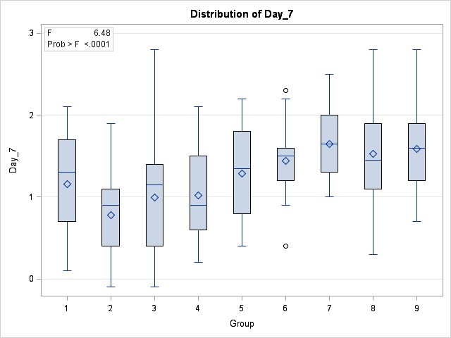

The GLM Procedure

Dependent Variable: Day_8

| **Source** | **DF** | **Sum of Squares** | **Mean Square** | **F Value** | **Pr > F** |
| --- | --- | --- | --- | --- | --- |
| **Model** | 8 | 10.64008085 | 1.33001011 | 13.62 | <.0001 |
| **Error** | 187 | 18.26415385 | 0.09766927 |  |  |
| **Corrected Total** | 195 | 28.90423469 |  |  |  |

| **R-Square** | **Coeff Var** | **Root MSE** | **Day_8 Mean** |
| --- | --- | --- | --- |
| 0.368115 | 19.79130 | 0.312521 | 1.579082 |

| **Source** | **DF** | **Type I SS** | **Mean Square** | **F Value** | **Pr > F** |
| --- | --- | --- | --- | --- | --- |
| **Group** | 8 | 10.64008085 | 1.33001011 | 13.62 | <.0001 |

| **Source** | **DF** | **Type III SS** | **Mean Square** | **F Value** | **Pr > F** |
| --- | --- | --- | --- | --- | --- |
| **Group** | 8 | 10.64008085 | 1.33001011 | 13.62 | <.0001 |

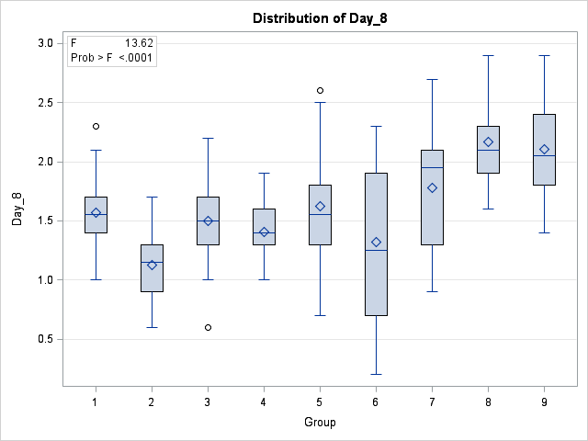

The GLM Procedure

Dependent Variable: Day_9

| **Source** | **DF** | **Sum of Squares** | **Mean Square** | **F Value** | **Pr > F** |
| --- | --- | --- | --- | --- | --- |
| **Model** | 8 | 7.23236656 | 0.90404582 | 17.13 | <.0001 |
| **Error** | 187 | 9.86865385 | 0.05277355 |  |  |
| **Corrected Total** | 195 | 17.10102041 |  |  |  |

| **R-Square** | **Coeff Var** | **Root MSE** | **Day_9 Mean** |
| --- | --- | --- | --- |
| 0.422920 | 11.38748 | 0.229725 | 2.017347 |

| **Source** | **DF** | **Type I SS** | **Mean Square** | **F Value** | **Pr > F** |
| --- | --- | --- | --- | --- | --- |
| **Group** | 8 | 7.23236656 | 0.90404582 | 17.13 | <.0001 |

| **Source** | **DF** | **Type III SS** | **Mean Square** | **F Value** | **Pr > F** |
| --- | --- | --- | --- | --- | --- |
| **Group** | 8 | 7.23236656 | 0.90404582 | 17.13 | <.0001 |

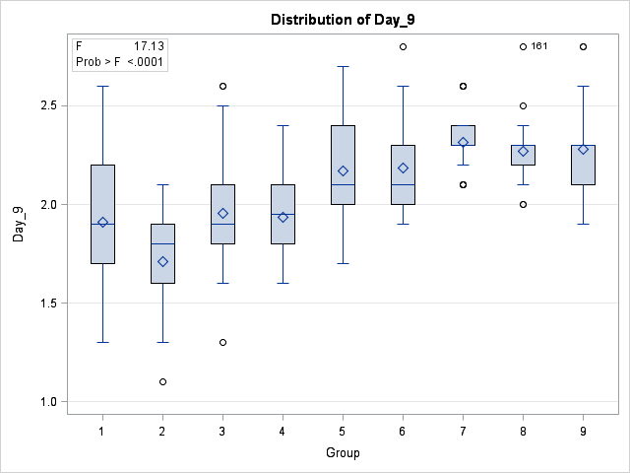

The GLM Procedure

Dependent Variable: Day_10

| **Source** | **DF** | **Sum of Squares** | **Mean Square** | **F Value** | **Pr > F** |
| --- | --- | --- | --- | --- | --- |
| **Model** | 8 | 5.09392595 | 0.63674074 | 4.46 | <.0001 |
| **Error** | 187 | 26.71301282 | 0.14285034 |  |  |
| **Corrected Total** | 195 | 31.80693878 |  |  |  |

| **R-Square** | **Coeff Var** | **Root MSE** | **Day_10 Mean** |
| --- | --- | --- | --- |
| 0.160151 | 21.09319 | 0.377955 | 1.791837 |

| **Source** | **DF** | **Type I SS** | **Mean Square** | **F Value** | **Pr > F** |
| --- | --- | --- | --- | --- | --- |
| **Group** | 8 | 5.09392595 | 0.63674074 | 4.46 | <.0001 |

| **Source** | **DF** | **Type III SS** | **Mean Square** | **F Value** | **Pr > F** |
| --- | --- | --- | --- | --- | --- |
| **Group** | 8 | 5.09392595 | 0.63674074 | 4.46 | <.0001 |

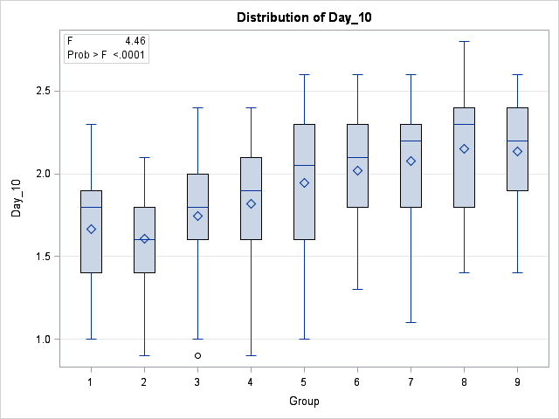

The GLM Procedure

Dependent Variable: Day_11

| **Source** | **DF** | **Sum of Squares** | **Mean Square** | **F Value** | **Pr > F** |
| --- | --- | --- | --- | --- | --- |
| **Model** | 8 | 6.24739220 | 0.78092403 | 5.72 | <.0001 |
| **Error** | 187 | 25.51112821 | 0.13642315 |  |  |
| **Corrected Total** | 195 | 31.75852041 |  |  |  |

| **R-Square** | **Coeff Var** | **Root MSE** | **Day_11 Mean** |
| --- | --- | --- | --- |
| 0.196715 | 17.11837 | 0.369355 | 2.157653 |

| **Source** | **DF** | **Type I SS** | **Mean Square** | **F Value** | **Pr > F** |
| --- | --- | --- | --- | --- | --- |
| **Group** | 8 | 6.24739220 | 0.78092403 | 5.72 | <.0001 |

| **Source** | **DF** | **Type III SS** | **Mean Square** | **F Value** | **Pr > F** |
| --- | --- | --- | --- | --- | --- |
| **Group** | 8 | 6.24739220 | 0.78092403 | 5.72 | <.0001 |

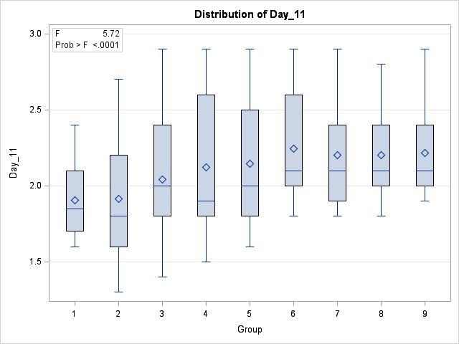

The GLM Procedure

Dependent Variable: Day_12

| **Source** | **DF** | **Sum of Squares** | **Mean Square** | **F Value** | **Pr > F** |
| --- | --- | --- | --- | --- | --- |
| **Model** | 8 | 11.54158477 | 1.44269810 | 7.14 | <.0001 |
| **Error** | 187 | 37.79938462 | 0.20213575 |  |  |
| **Corrected Total** | 195 | 49.34096939 |  |  |  |

| **R-Square** | **Coeff Var** | **Root MSE** | **Day_12 Mean** |
| --- | --- | --- | --- |
| 0.233915 | 26.69513 | 0.449595 | 1.684184 |

| **Source** | **DF** | **Type I SS** | **Mean Square** | **F Value** | **Pr > F** |
| --- | --- | --- | --- | --- | --- |
| **Group** | 8 | 11.54158477 | 1.44269810 | 7.14 | <.0001 |

| **Source** | **DF** | **Type III SS** | **Mean Square** | **F Value** | **Pr > F** |
| --- | --- | --- | --- | --- | --- |
| **Group** | 8 | 11.54158477 | 1.44269810 | 7.14 | <.0001 |

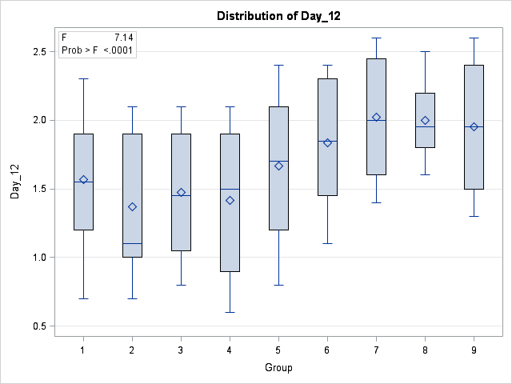

The GLM Procedure

Dependent Variable: Day_13

| **Source** | **DF** | **Sum of Squares** | **Mean Square** | **F Value** | **Pr > F** |
| --- | --- | --- | --- | --- | --- |
| **Model** | 8 | 12.06680508 | 1.50835063 | 11.08 | <.0001 |
| **Error** | 187 | 25.45620513 | 0.13612944 |  |  |
| **Corrected Total** | 195 | 37.52301020 |  |  |  |

| **R-Square** | **Coeff Var** | **Root MSE** | **Day_13 Mean** |
| --- | --- | --- | --- |
| 0.321584 | 26.13503 | 0.368957 | 1.411735 |

| **Source** | **DF** | **Type I SS** | **Mean Square** | **F Value** | **Pr > F** |
| --- | --- | --- | --- | --- | --- |
| **Group** | 8 | 12.06680508 | 1.50835063 | 11.08 | <.0001 |

| **Source** | **DF** | **Type III SS** | **Mean Square** | **F Value** | **Pr > F** |
| --- | --- | --- | --- | --- | --- |
| **Group** | 8 | 12.06680508 | 1.50835063 | 11.08 | <.0001 |

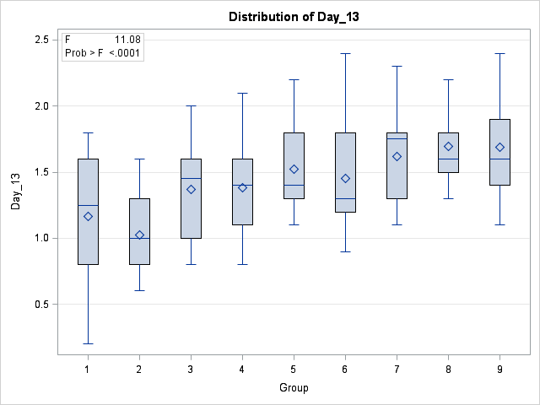

The GLM Procedure

Dependent Variable: Day_14

| **Source** | **DF** | **Sum of Squares** | **Mean Square** | **F Value** | **Pr > F** |
| --- | --- | --- | --- | --- | --- |
| **Model** | 8 | 12.02153035 | 1.50269129 | 49.10 | <.0001 |
| **Error** | 187 | 5.72255128 | 0.03060188 |  |  |
| **Corrected Total** | 195 | 17.74408163 |  |  |  |

| **R-Square** | **Coeff Var** | **Root MSE** | **Day_14 Mean** |
| --- | --- | --- | --- |
| 0.677495 | 10.50461 | 0.174934 | 1.665306 |

| **Source** | **DF** | **Type I SS** | **Mean Square** | **F Value** | **Pr > F** |
| --- | --- | --- | --- | --- | --- |
| **Group** | 8 | 12.02153035 | 1.50269129 | 49.10 | <.0001 |

| **Source** | **DF** | **Type III SS** | **Mean Square** | **F Value** | **Pr > F** |
| --- | --- | --- | --- | --- | --- |
| **Group** | 8 | 12.02153035 | 1.50269129 | 49.10 | <.0001 |

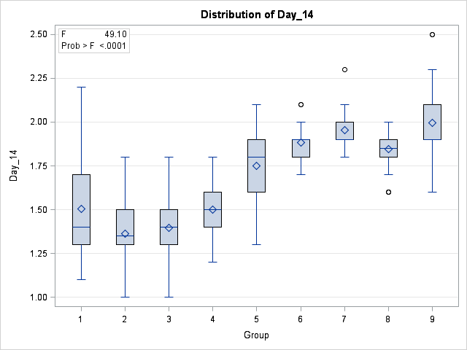

The GLM Procedure

Dependent Variable: Day_15

| **Source** | **DF** | **Sum of Squares** | **Mean Square** | **F Value** | **Pr > F** |
| --- | --- | --- | --- | --- | --- |
| **Model** | 8 | 2.59661591 | 0.32457699 | 2.95 | 0.0040 |
| **Error** | 187 | 20.58828205 | 0.11009776 |  |  |
| **Corrected Total** | 195 | 23.18489796 |  |  |  |

| **R-Square** | **Coeff Var** | **Root MSE** | **Day_15 Mean** |
| --- | --- | --- | --- |
| 0.111996 | 20.17206 | 0.331810 | 1.644898 |

| **Source** | **DF** | **Type I SS** | **Mean Square** | **F Value** | **Pr > F** |
| --- | --- | --- | --- | --- | --- |
| **Group** | 8 | 2.59661591 | 0.32457699 | 2.95 | 0.0040 |

| **Source** | **DF** | **Type III SS** | **Mean Square** | **F Value** | **Pr > F** |
| --- | --- | --- | --- | --- | --- |
| **Group** | 8 | 2.59661591 | 0.32457699 | 2.95 | 0.0040 |

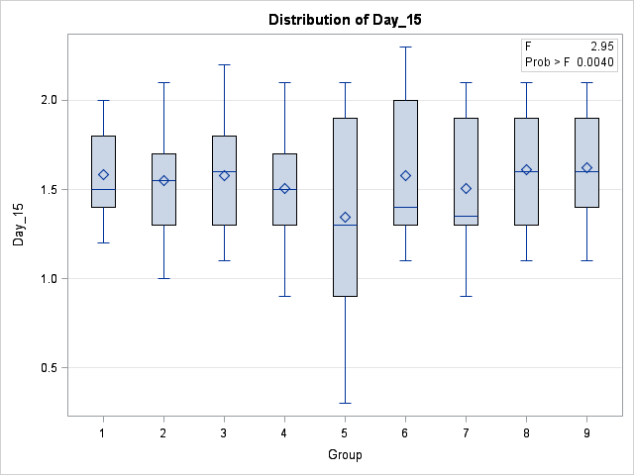

The GLM Procedure

Repeated Measures Analysis of Variance

| **Repeated Measures Level Information** | | | | | | | | | | | | | | | |
| --- | --- | --- | --- | --- | --- | --- | --- | --- | --- | --- | --- | --- | --- | --- | --- |
| **Dependent Variable** | **Day_1** | **Day_2** | **Day_3** | **Day_4** | **Day_5** | **Day_6** | **Day_7** | **Day_8** | **Day_9** | **Day_10** | **Day_11** | **Day_12** | **Day_13** | **Day_14** | **Day_15** |
| **Level of Time** | 1 | 2 | 3 | 4 | 5 | 6 | 7 | 8 | 9 | 10 | 11 | 12 | 13 | 14 | 15 |

| **MANOVA Test Criteria and Exact F Statistics for the Hypothesis of no Time Effect H = Type III SSCP Matrix for Time E = Error SSCP Matrix  S=1 M=6 N=86** | | | | | |
| --- | --- | --- | --- | --- | --- |
| **Statistic** | **Value** | **F Value** | **Num DF** | **Den DF** | **Pr > F** |
| **Wilks' Lambda** | 0.04976543 | 237.31 | 14 | 174 | <.0001 |
| **Pillai's Trace** | 0.95023457 | 237.31 | 14 | 174 | <.0001 |
| **Hotelling-Lawley Trace** | 19.09426907 | 237.31 | 14 | 174 | <.0001 |
| **Roy's Greatest Root** | 19.09426907 | 237.31 | 14 | 174 | <.0001 |

| **MANOVA Test Criteria and F Approximations for the Hypothesis of no Time*Group Effect H = Type III SSCP Matrix for Time*Group E = Error SSCP Matrix  S=8 M=2.5 N=86** | | | | | |
| --- | --- | --- | --- | --- | --- |
| **Statistic** | **Value** | **F Value** | **Num DF** | **Den DF** | **Pr > F** |
| **Wilks' Lambda** | 0.08856073 | 4.54 | 112 | 1231.8 | <.0001 |
| **Pillai's Trace** | 1.77123254 | 3.68 | 112 | 1448 | <.0001 |
| **Hotelling-Lawley Trace** | 3.63141680 | 5.59 | 112 | 827.77 | <.0001 |
| **Roy's Greatest Root** | 2.00079408 | 25.87 | 14 | 181 | <.0001 |
| **NOTE: F Statistic for Roy's Greatest Root is an upper bound.** | | | | | |

The GLM Procedure

Repeated Measures Analysis of Variance

Tests of Hypotheses for Between Subjects Effects

| **Source** | **DF** | **Type III SS** | **Mean Square** | **F Value** | **Pr > F** |
| --- | --- | --- | --- | --- | --- |
| **Group** | 8 | 178.9790248 | 22.3723781 | 45.91 | <.0001 |
| **Error** | 187 | 91.1216419 | 0.4872815 |  |  |

The GLM Procedure

Repeated Measures Analysis of Variance

Univariate Tests of Hypotheses for Within Subject Effects

| **Source** | **DF** | **Type III SS** | **Mean Square** | **F Value** | **Pr > F** | **Adj Pr > F** | |
| --- | --- | --- | --- | --- | --- | --- | --- |
| **G - G** | **H-F-L** |
| **Time** | 14 | 334.7844355 | 23.9131740 | 170.31 | <.0001 | <.0001 | <.0001 |
| **Time*Group** | 112 | 69.1697369 | 0.6175869 | 4.40 | <.0001 | <.0001 | <.0001 |
| **Error(Time)** | 2618 | 367.5835761 | 0.1404063 |  |  |  |  |

|  |  |
| --- | --- |
| **Greenhouse-Geisser Epsilon** | 0.3353 |
| **Huynh-Feldt-Lecoutre Epsilon** | 0.3450 |